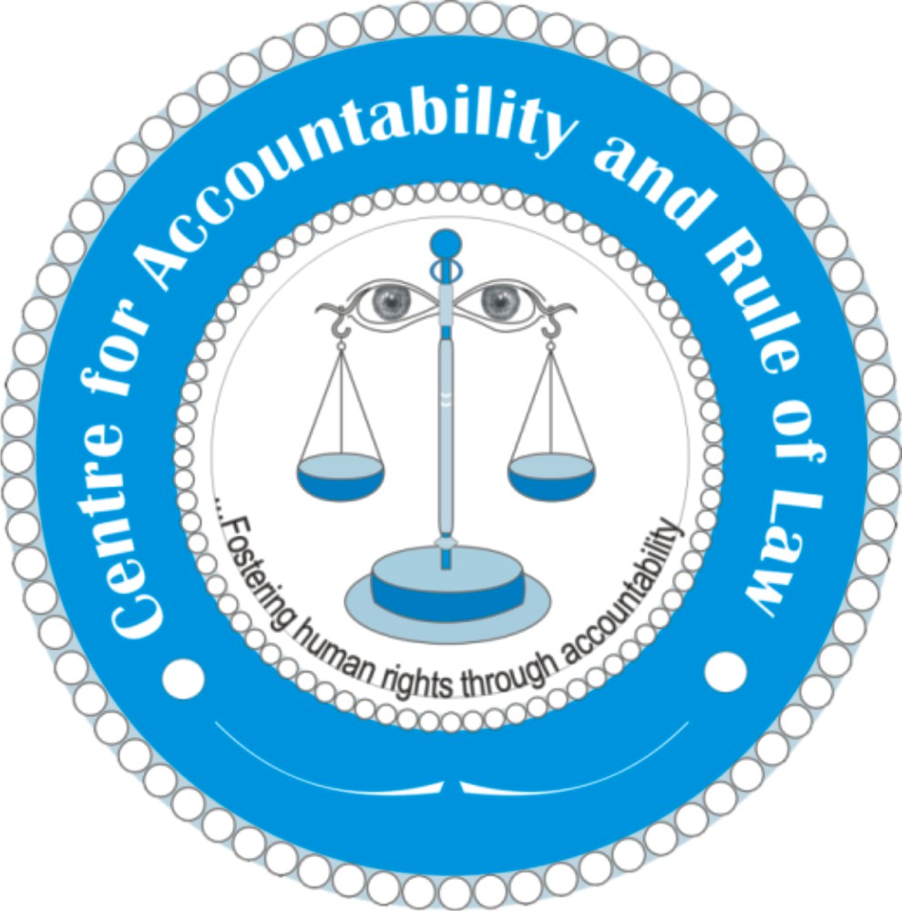
Centre for Accountability and Rule of Law (CARL-SL)
19 Pultney Street Freetown, Sierra Leone
Tel: +232 76 672 841
Email: info@carl-sl.org, www.carl-sl.org

Press Statement
July 30th, 2025
Freetown, Sierra Leone: Centre for accountability and Rule of Law condemns corruption in the Ministry of Basic and Senior Secondary School Education; calls for accountability for ghost workers in the payroll of various schools across the country:
The Centre for Accountability and Rule of Law, Sierra Leone (CARL) is gravely concerned by a recent memorandum authored by the Teaching Service Commission (TSC) and released by the Ministry of Finance indicating that the Government of Sierra Leone has been disbursing huge sums of money to four thousand six hundred and sixty-two (4,662) ghost workers across the country, resulting in the loss of significant sums of public funds.
The memorandum, dated 24th July, 2025 and addressed to various banking institutions, states that the “ghost workers” were discovered after a physical verification exercise conducted by the TSC this year. It further requests the various banks listed in the memorandum to “furnish the Ministry of Finance with comprehensive information relating to the status of the accounts” of the teachers listed in the memorandum as well as withdrawals for the period January through June, 2025.
We commend the TSC for its ongoing efforts to ensure accountability in the delivery of public services, especially as it relates to the payment of salaries. We sincerely hope that the Ministry of Finance will ensure that these names are deleted from the payroll and all funds fully recovered.
“The presence of “ghost workers” in the public service payroll has gone on for several years,” said Jeremy Ben Simbo, CARL’s Head of Programmes, adding that “it may have been part of a criminal scheme to siphon public funds into the pockets of individuals across the relevant ministries and departments”
Public officials have over the years used different methods to defraud the state of funds needed to provide basic services.
“It wasn’t a mistake,” Mr. Ben Simbo said, adding that “it looks like a plain criminal enterprise designed, planned and implemented by key actors across the ministries, agencies and school administrators concerned”.
Whilst CARL commends the ongoing efforts by the Ministry of Finance to recover the funds, we urge the Anti-Corruption Commission to spare no efforts in ensuring not just a full recovery of the said sums but also a thorough investigation of the circumstances leading to the disbursement of those funds and where there is credible evidence of criminal intent, those responsible should be brought to justice.
We further demand that the Ministry of Basic and Senior Secondary School Education and the Ministry of Finance make a clear statement on this unfortunate and unacceptable development by not only suspending those suspected to have participated in this criminal scheme, but by also withholding the salaries and any benefits due them until the investigation is concluded.
There is no doubt that corruption constitutes a binding constraint to Sierra Leone’s development efforts, and unless state actors who conspire to undermine the delivery of basic social and economic services through corruption are held accountable, the economic and social development aspirations of the people of Sierra Leone will never be achieved. At a time when the country is struggling to satisfy its domestic and foreign debt obligations as well as provide basic social and economic services to the people of Sierra Leone, we should leave no stones unturned to bring to justice those who defraud the Government and people of Sierra Leone.
For further clarification, please feel free to contact Mr. Jeremy Ben Simbo, Head of Programmes, CARL-SL on: +232 76-672841 or email: simbojeremy@yahoo.com

#THE END#

